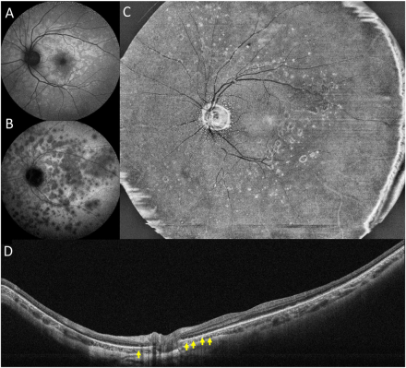

A 36-year-old woman underwent a multimodal imagingexamination. Autofluorescence (A) and indocyanine green angiography (B) were consistent with typical MEWDS features. Additionally, enface OCT image (at the level of the outer retina) (C) obtained from ultrawide-field swept-source OCT angiography revealed smallhyperreflective dots around the optic nerve and confluent hyperreflective spots disseminated at the midperipheral retina. The OCT B-scan(D) confirmed multiple hyperreflective dots (yellow arrows) that corresponded with the findings on the en face OCT. Based on the provided images and clinical description please make an ophthalmic diagnosis for this patient. And output the diagnostic conclusions only.

**Multiple Evanescent White Dot Syndrome (MEWDS).**